General Instructions for Using Jitsi Meet

1. Introduction
Jitsi Meet is an open-source video conferencing platform that allows users to host and join online meetings easily using a web browser or mobile app. It supports video calls, screen sharing, chat, recording (if enabled), and secure meeting options.

2. How to Start a Meeting (Using Browser)
Step 1: Open your meeting URL (for example: https://meet.yourdomain.com).
Step 2: Enter a unique meeting name.
Step 3: Click 'Start Meeting'.
Step 4: Allow microphone and camera permissions when prompted.
You are now inside the meeting room.
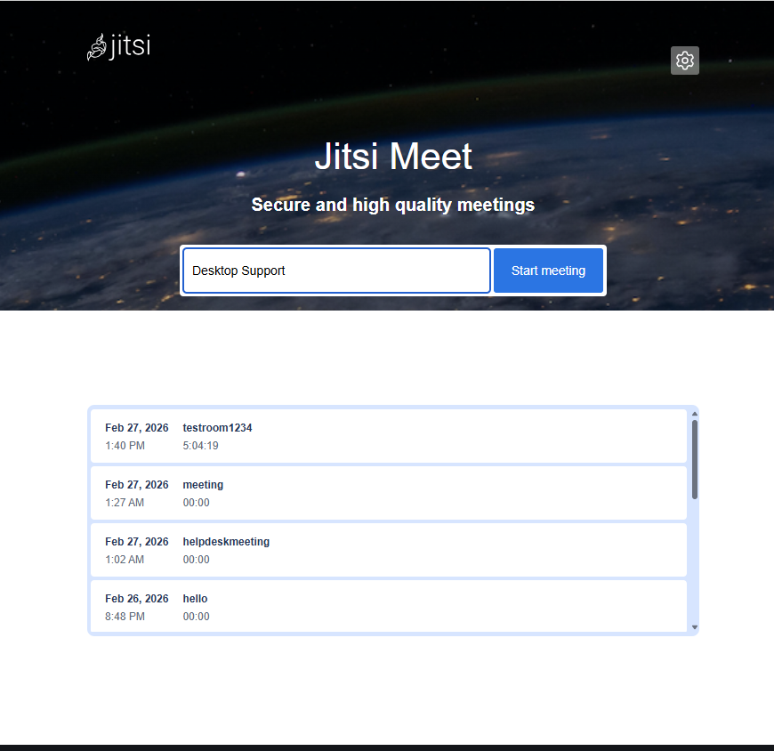

3. How to Invite Participants
After joining the meeting:
1. Click the Participants icon.
2. Click Invite.
3. Copy the meeting link.
4. Share it via email, WhatsApp, SMS, or other communication tools.
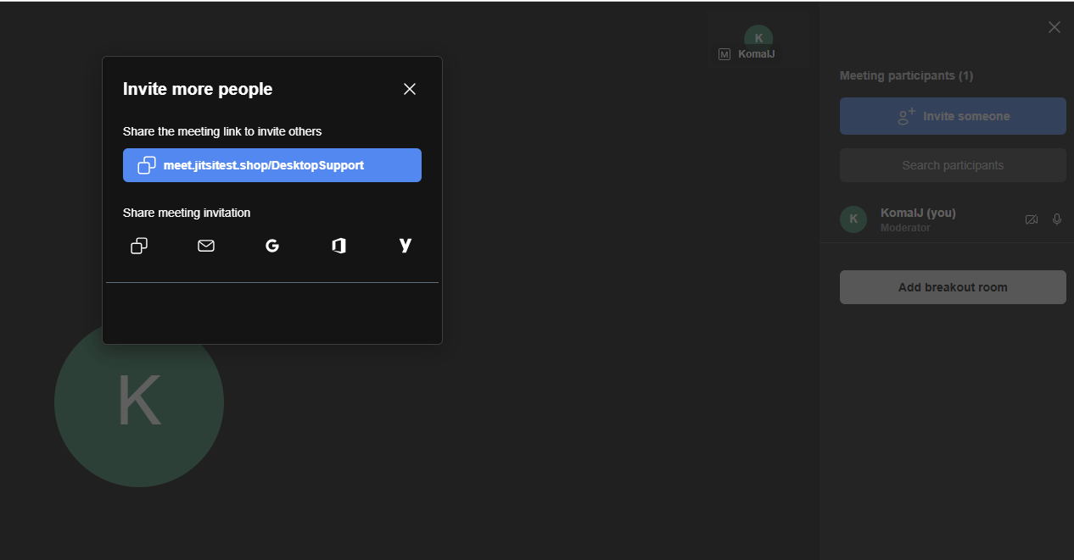

4. Basic Meeting Controls
• Mute/Unmute microphone
• Start/Stop camera
• Share screen
• Open chat
• Raise hand
• More options (settings, recording, etc.)
• Leave meeting

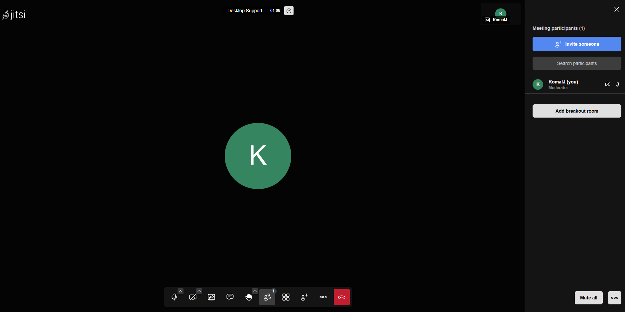

5. How to Share Screen
1. Click the 'Share Screen' button.
2. Select Entire Screen, Window, or Browser Tab.
3. Click Share.
Screen sharing is useful for presentations, training sessions, and technical demonstrations.
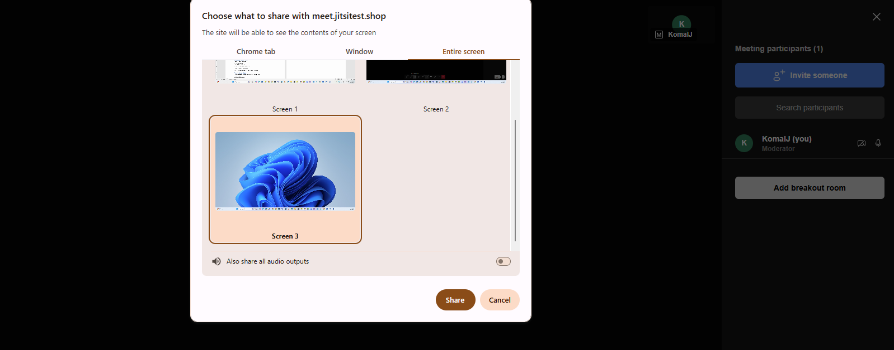

6. Recording a Meeting (If Enabled)
1. Click the 'More options' menu.
2. Select 'Start recording'.
3. Stop recording when finished.
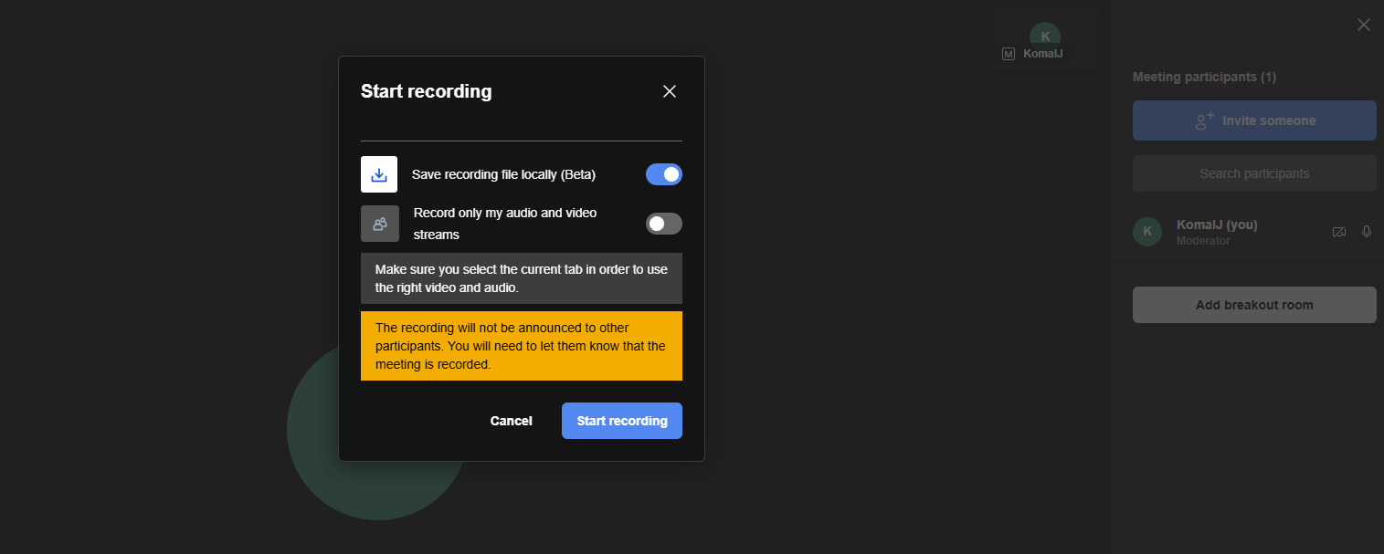

7. Best Practices for Smooth Meetings
• Use stable internet
• Keep microphone muted when not speaking.
• Use headphones to avoid echo.
• Close unnecessary background applications.
• Use updated browser (Chrome recommended).

8. Common Troubleshooting
No audio – Check microphone permissions.
Camera not working – Verify camera access.
Poor quality – Reduce video resolution in settings.
Connection drops – Check firewall and network stability.

Using Jitsi on Mobile
1. Install the Jitsi Meet app from Play Store or App Store.
2. Open the app.
3. Enter meeting name.
4. Tap Join and allow permissions.
